Alexandra Keith
ArcGIS
Question 1- I picked the Openstreet map for my basemap. I picked that one because it was my favorite and I am able to see the different streets and I can clearly see the lines separating the states and the cities. It is easier for me to see it and I like it the best. Data that would work with this kind of basemap is knowing where certain streets are or how far away one point is from another by looking at it.
Question 2- The highest income group is the dark green with more than 82,000. The lowest is the yellow with 24,000 or less.
Question 3- The relationship I see between the two layers is that the trolley line goes through all the blocks that have an income of 39,001 to 53,000.
Question 4- The blue line runs parallel to the fault line.
Question 5- Pacific plate.
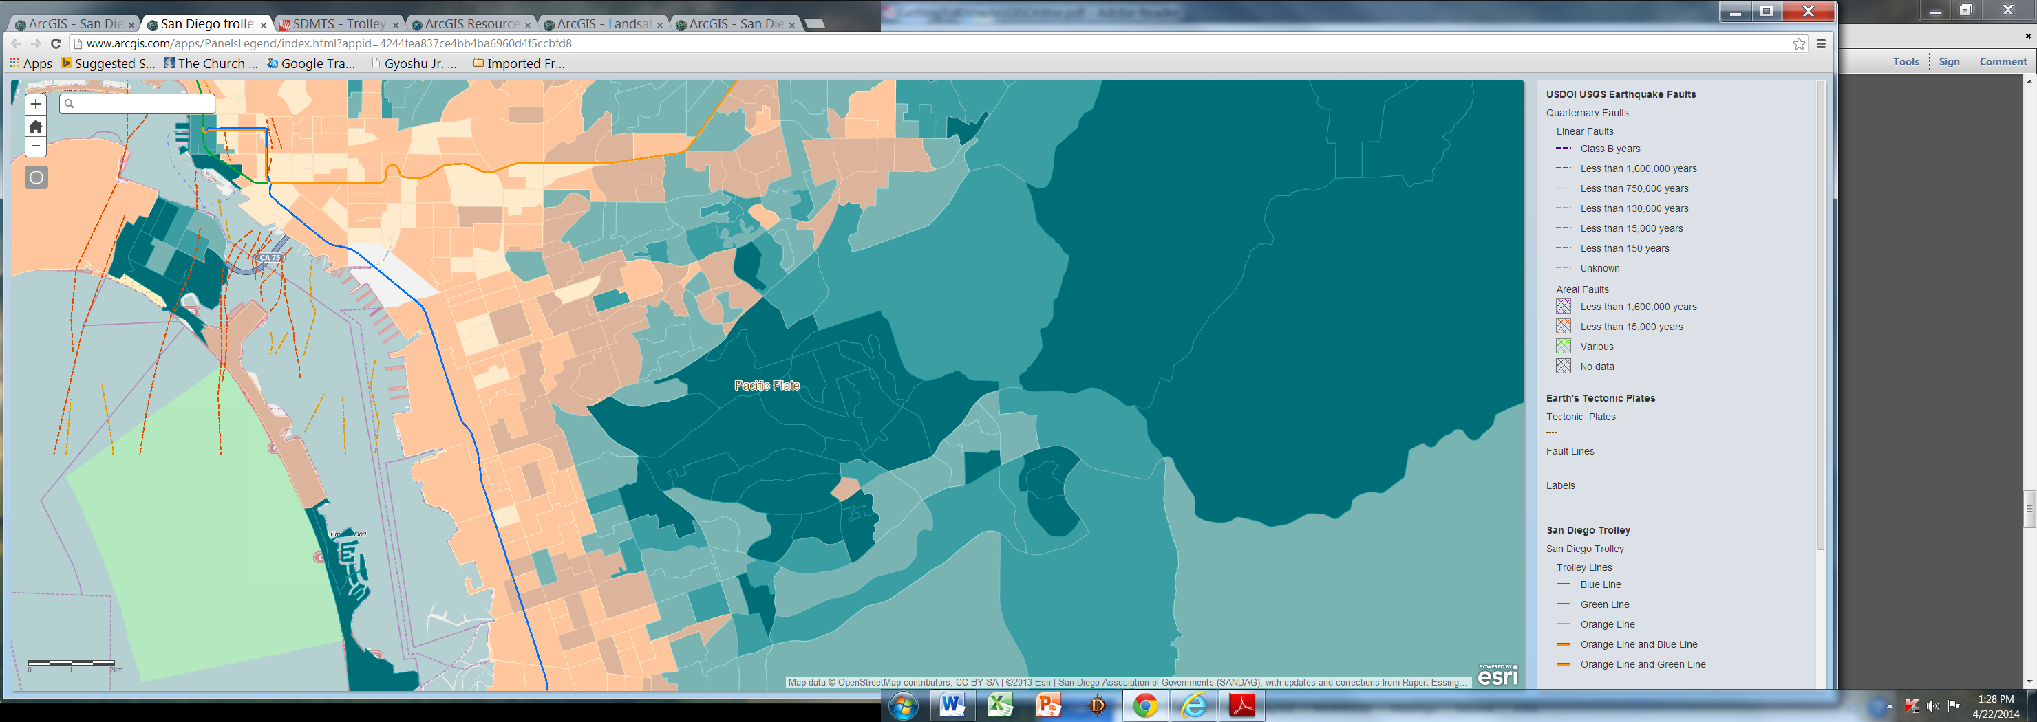
Question 7- I preferred Maps because it was easier for me to understand. I think maps are best for publication and display.
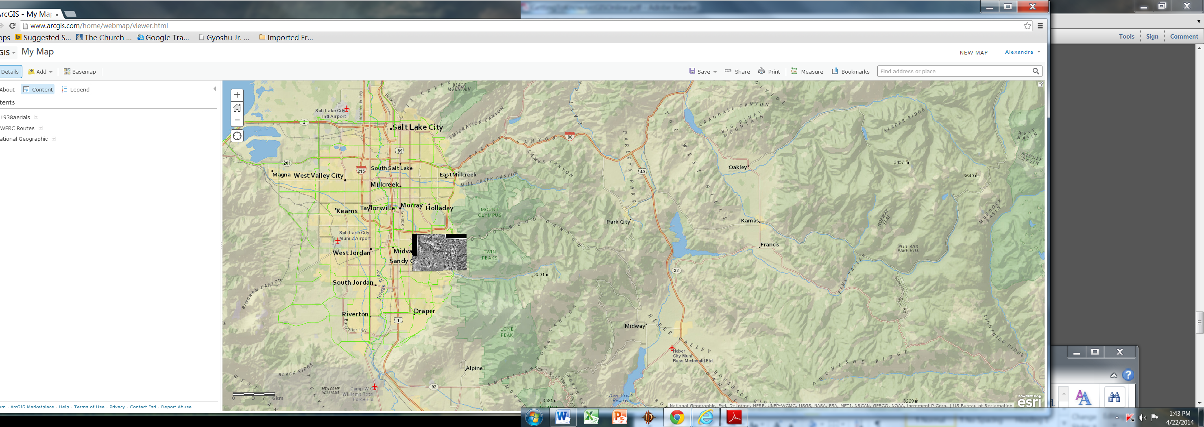
When I created a map I decided to look at the area where the Wasatch front fault line was at. I also decided to locate a hiking place in Draper where I like to hike and it showed a picture and it shows it is right by the fault where I like to hike.
http://bit.ly/1icQh4P
Question 9- http://www.arcgis.com/apps/Solutions/s2.html?appid=e288da4570fe4b64bebf18678f2d3741

